Navigation Bar Overview

1) Navigation Bar Left Side
Holmes Sales Group, Inc.
Building Product Specification Specialist

2) Navigation Bar Right Side
The Issue
Services Offered|
Projects |
About HSG |
Pricing |
Free Audit

Hero Section Overview
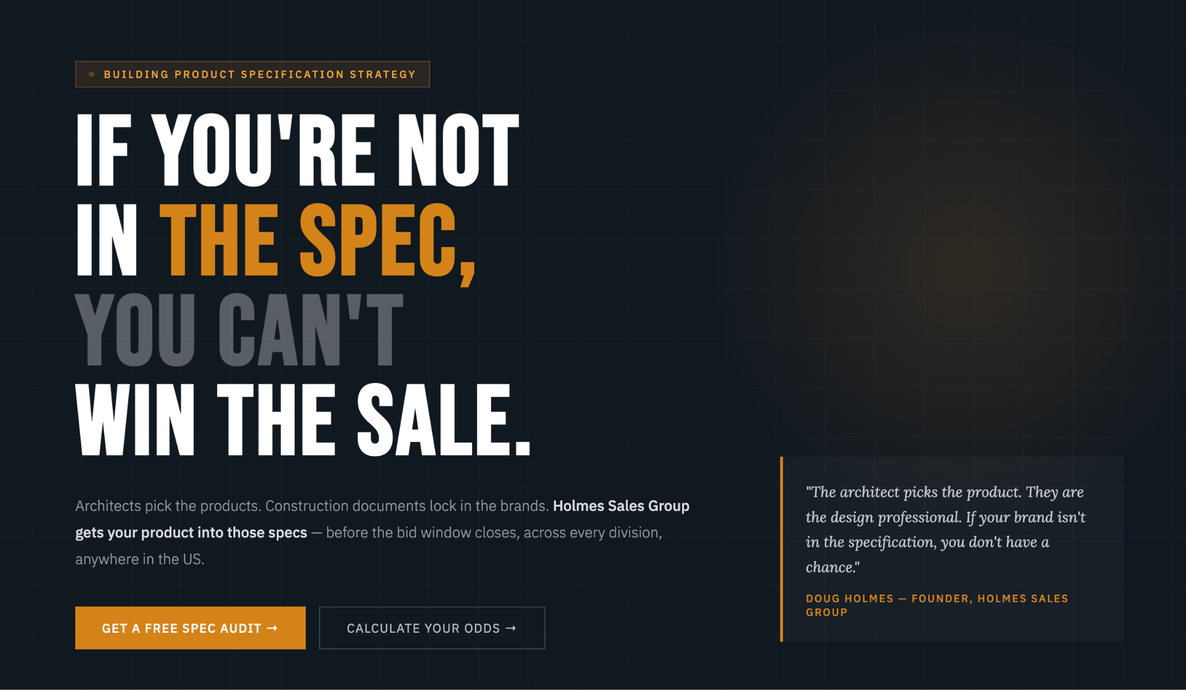

1) Hero Section Left Side
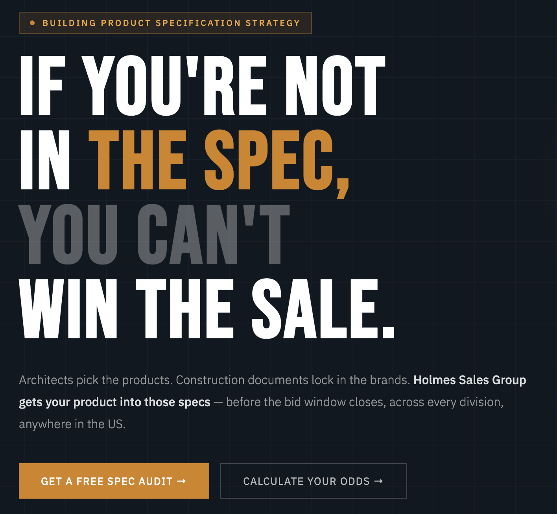
Building Product Specification Strategy

If you’re not in the spec, you can’t win the sale.
Holmes Sales Group partners with building product manufacturers to drive specification, sales, and market expansion.

We work as an extension of your team—securing product placement in architectural specifications through focused A&D outreach and presentations, supporting the path from spec to purchase, and helping you strengthen market coverage. In addition, we identify and place proven A&D and territory sales representatives who understand your product, your channel, and your regional goals. Our role is simple: help manufacturers get specified, create market awarness, and win more projects.

Get A Free Spec Audit ->

2) Hero Section Right Side

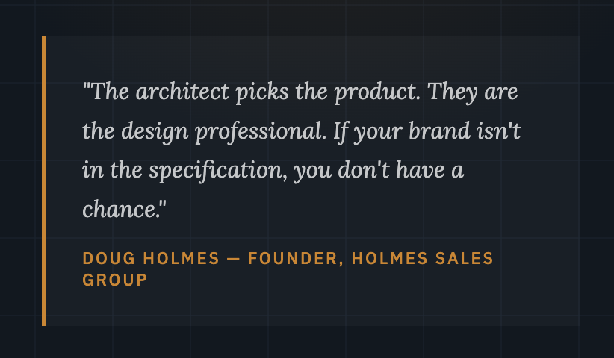

“Specifications decide the playing field-if your product isn’t listed, you are not in the game”
Doug Holmes - Founder, Holmes Sales Group

Ticker Overview

Ticker Section Items:

Division 7 — Thermal & Moisture
Industrial Door Systems
Operable Partitions/Glass Operable Partitions
Demountable Partitions
Architectural Hardware Systems
Exterior Thermal Rated Folding and Sliding Doors
Flooring
Building Enclosure/Rainscreen Assemblies
Acoustical Ceilings and Wall Panels
A&D Outreach
AIA/CES Presentations
CSI Certified
Nationwide Reach

Problem Overview/The Solution

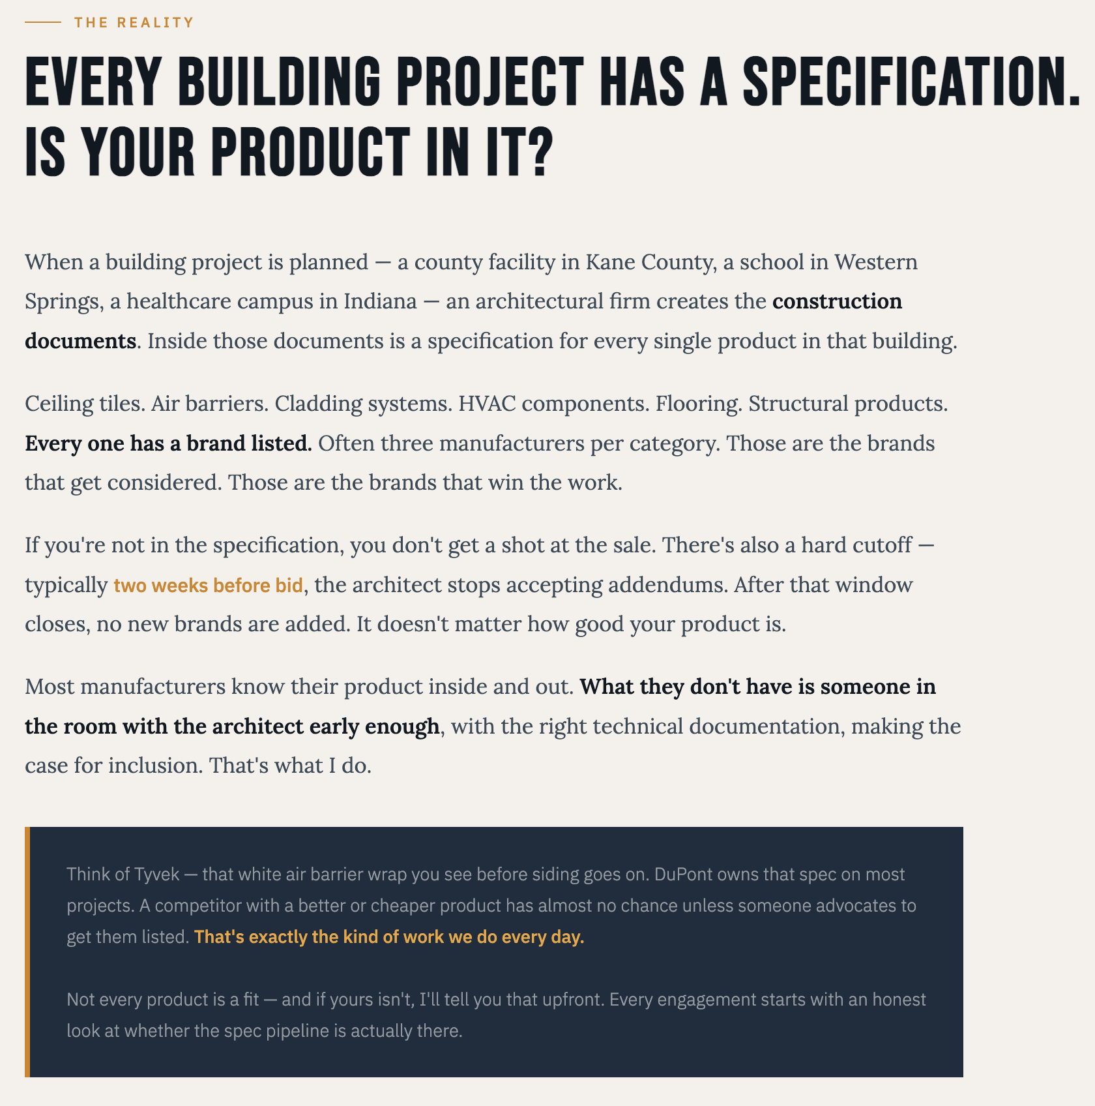

The Reality
Every Building Product Has a Specification Catagory.
Is Your Product In It?
Holmes Sales Group partners with building product manufacturers to drive specification, sales, and market expansion. We work as an extension of your team—securing product placement in architectural specifications through focused A&D outreach and presentations, supporting the path from spec to purchase, and helping you strengthen market coverage. In addition, we identify and place proven A&D and territory sales representatives who understand your product, your channel, and your regional goals. Our role is simple: help manufacturers gain traction, build momentum, and win more projects.Every manufacturer is different, so our approach is never one-size-fits-all.
Our Approach
We believe relationships matter. Trust matters. Follow-through matters.
We focus on long-term growth, not quick wins. When your product is specified, approved, and installed—that’s success to us.

How It Works Overview

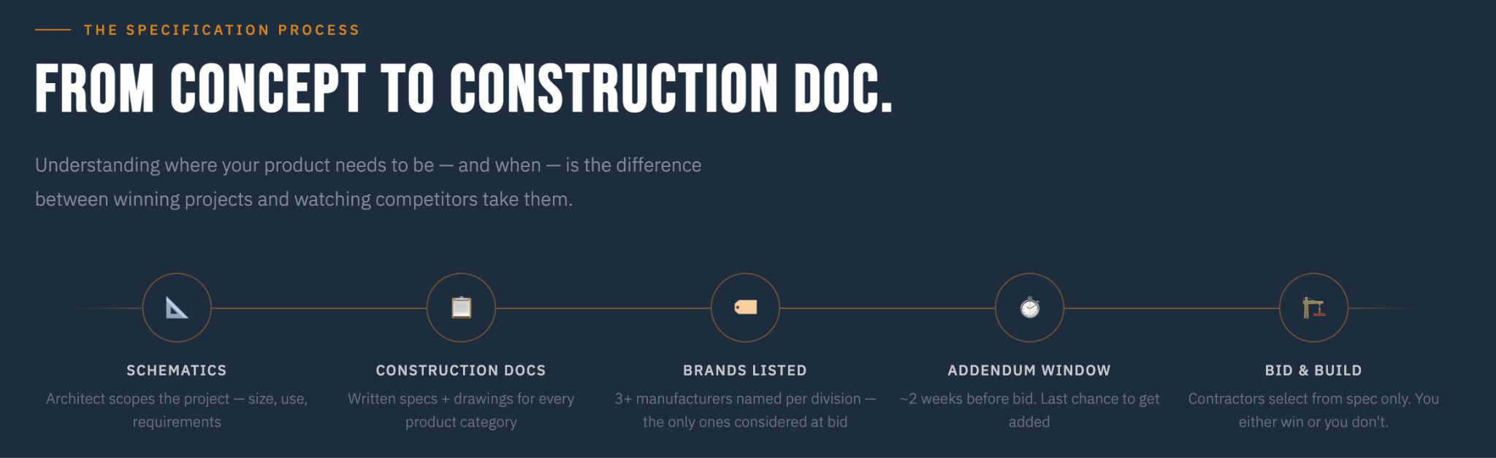

The Specification Process
From Concept to Construction Doc.
Understanding where your product needs to be — and when — is the difference between winning projects and watching competitors take them.
📐 Schematics
Architect and V Building Owner scopes the project — size, use, requirements
📋Design Deveolpment
Written specs + products selected + drawings for every product category
🏷️ Construction Documents
3+ manufacturers named per division — the only ones considered at bid
⏱️ Addendum Window
~2 weeks before bid. Last chance to get added
🏗️ Bid & Award
Contractors select from spec only. You either win or you don't.

Projects Overview
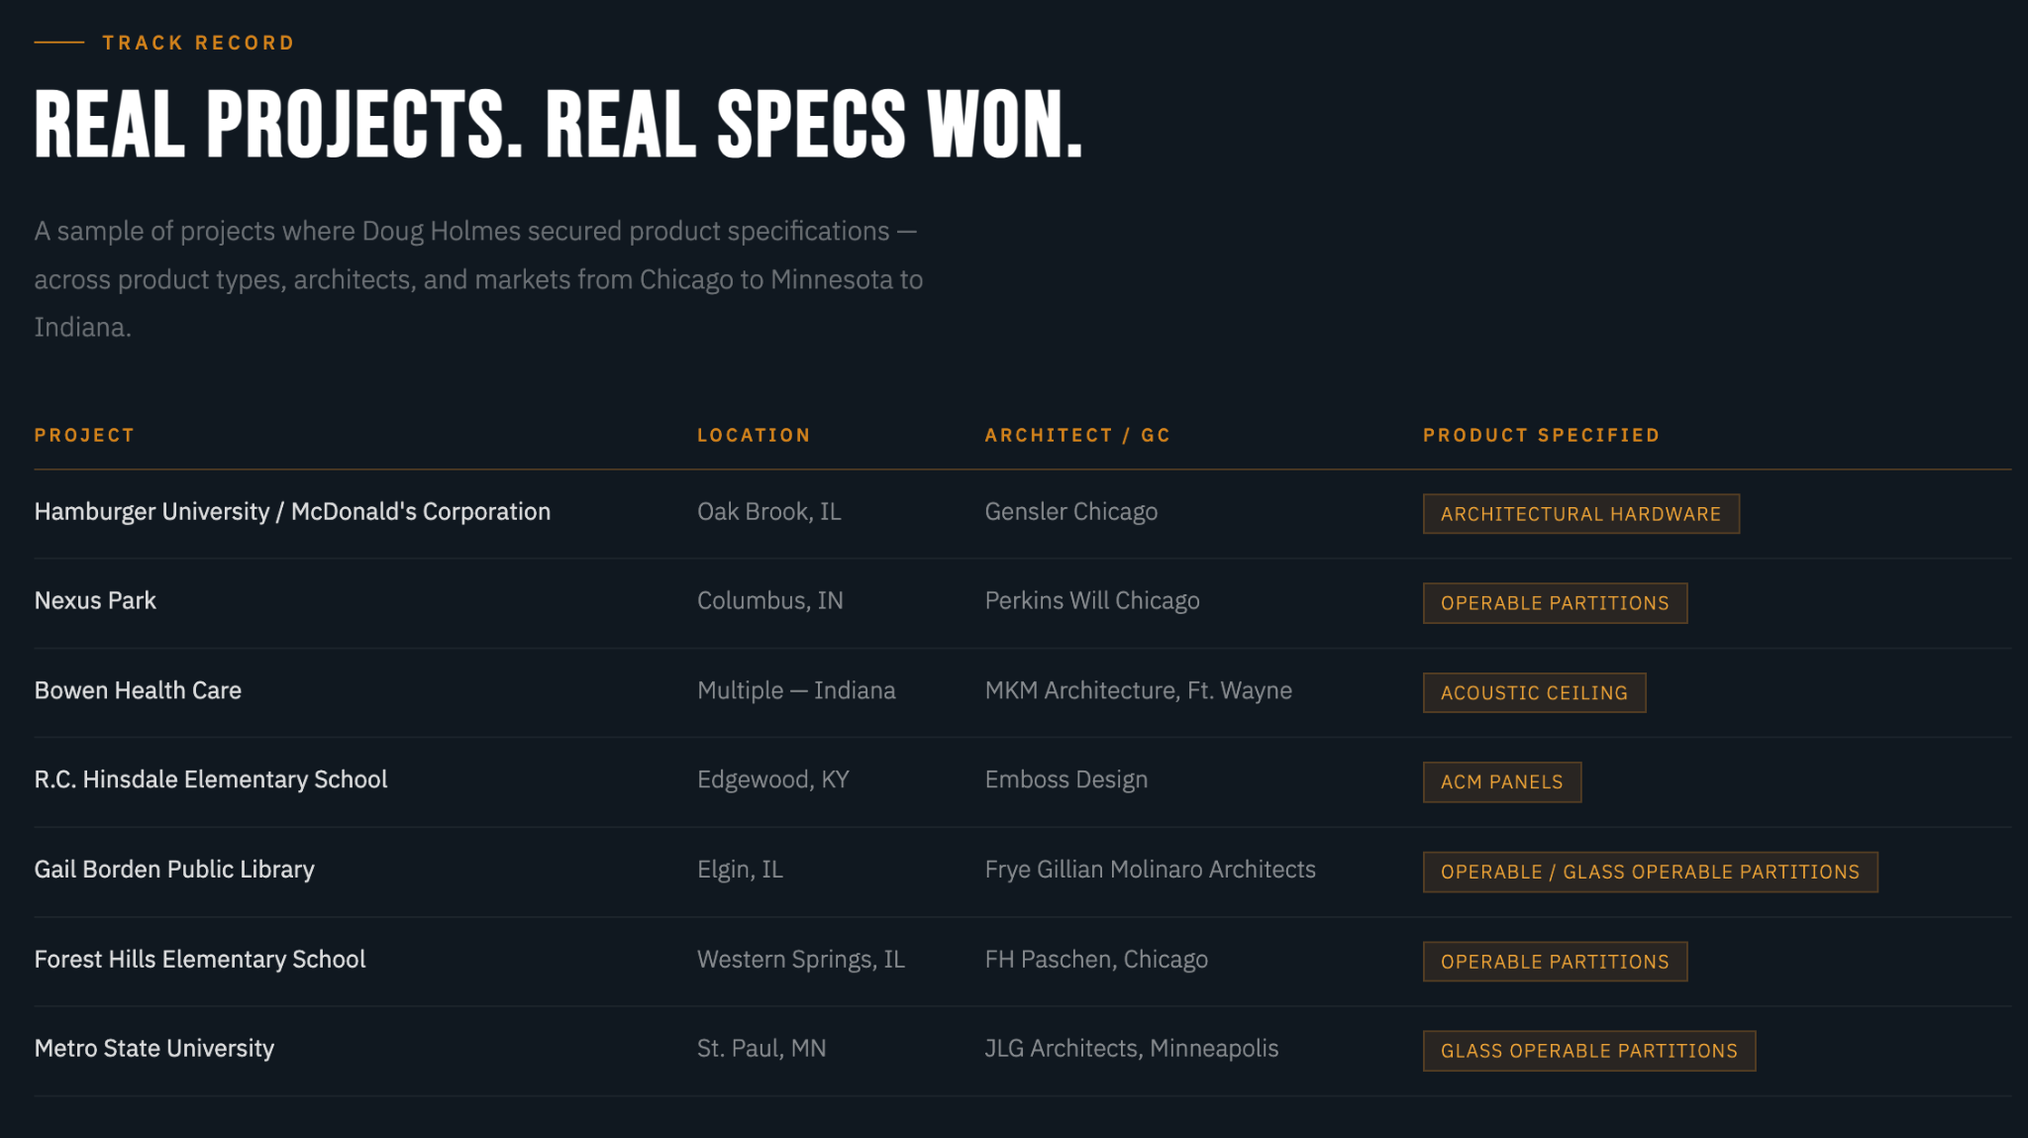
Track Record
Real Projects. Real Specs Won.
A sample of projects where Doug Holmes secured product specifications — across product types, architects, and markets from Chicago to Minnesota to Indiana.
Projects
Hamburger University / McDonald's Corporation
Oak Brook, IL
Gensler/Chicago
Architectural Hardware
Nexus Park
Columbus, IN
Perkins Wil/Chicago
Operable Partitions
Bowen Health Care
Multiple — Indiana
MKM Architecture, Ft. Wayne
Acoustic Ceiling
R.C. Hinsdale Elementary School
Edgewood, KY
Emboss Design
ACM Panels
Gail Borden Public Library
Elgin, IL
Frye Gillian Molinaro Architects
Operable / Glass Operable Partitions
Forest Hills Elementary School
Western Springs, IL
FH Paschen, Chicago
Operable Partitions
Metro State University
St. Paul, MN
JLG Architects, Minneapolis
Glass Operable Partitions
Kellogg School of Business, Northwestern University,
Evanston, IL
Architect: KPMP Architects, Toronto, ON
Tile Flooring

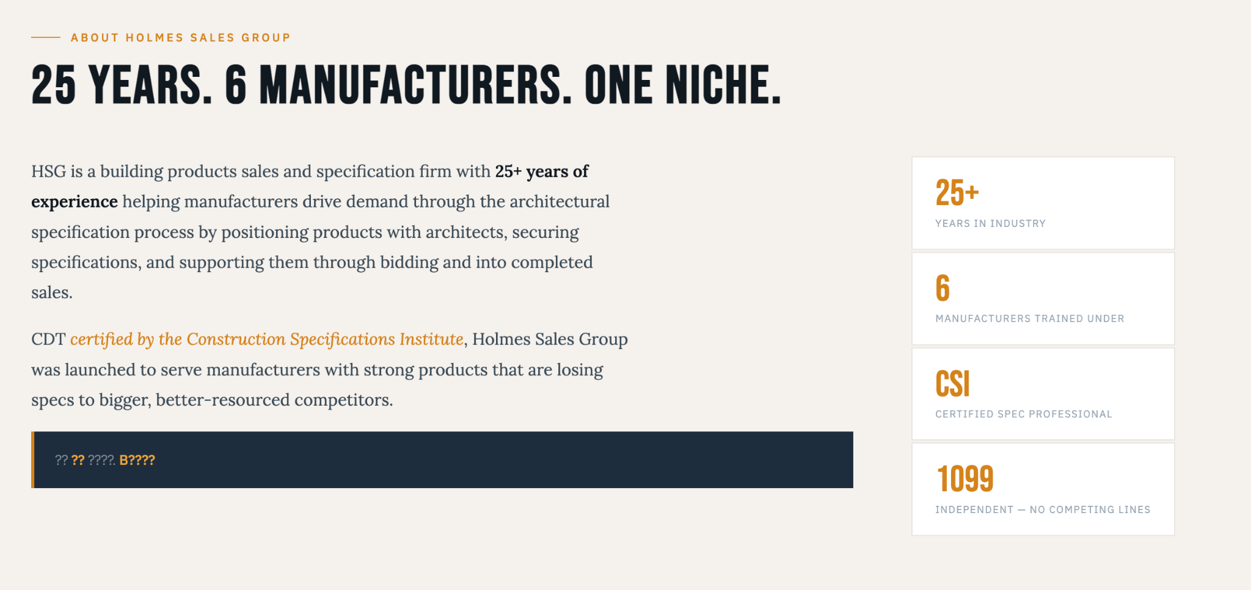
About Holmes Sales Group
25 Years. 6 Manufacturers. One Niche.
HSG is a building products sales and specification firm with 25+ years of experience helping manufacturers drive demand through the architectural specification process by positioning products with architects, securing specifications, and supporting them through bidding and into completed sales.
CDT certified by the Construction Specifications Institute, Holmes Sales Group was launched to serve manufacturers with strong products that are losing specs to bigger, better-resourced competitors.

25+
Years in Industry
6
Manufacturers Trained Under
Certified Documents Technologist (CDT) Issued by
The Construction Specification Institute (CSI)

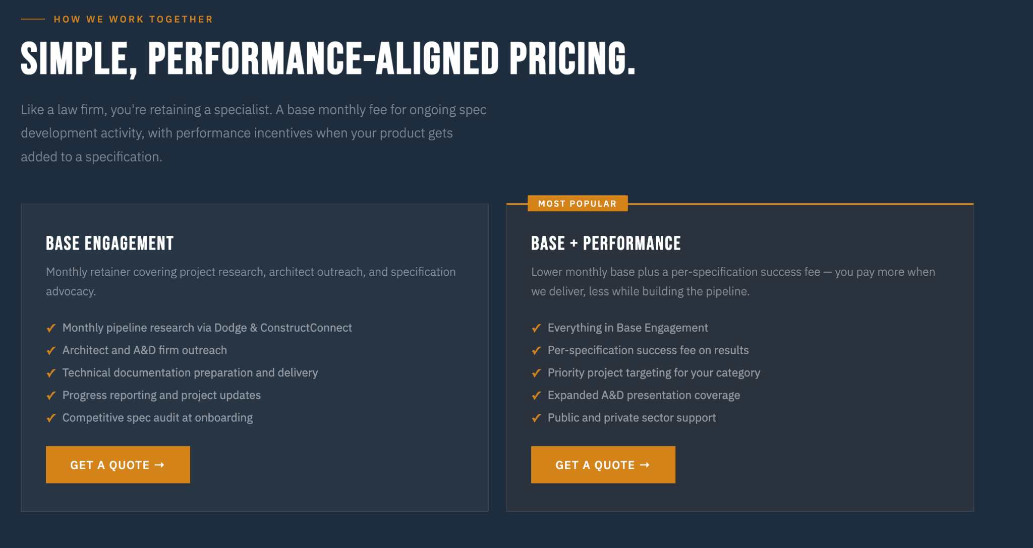
How We Work Together
Simple, Performance-Aligned Pricing.
A monthly fee base for ongoing spec development activity, with performance incentives when your product gets added to a specification.

Base Engagement
Monthly retainer covering project research, architect outreach, and specification advocacy.
Includes:
- Monthly pipeline research via Building Project Data Search
- Architect outreach, product approval request
- Technical documentation preparation and delivery
- Progress reporting and project updates
Get a Quote →

Most Popular

Base + Performance
Lower monthly base plus a per-specification success fee — you pay more when we deliver, less while building the pipeline.
Includes:
- Everything in Base Engagement
- Per-specification success fee on results
- Priority project targeting for your category
- Expanded A&D presentation coverage
- Public sector support
Get a Quote →
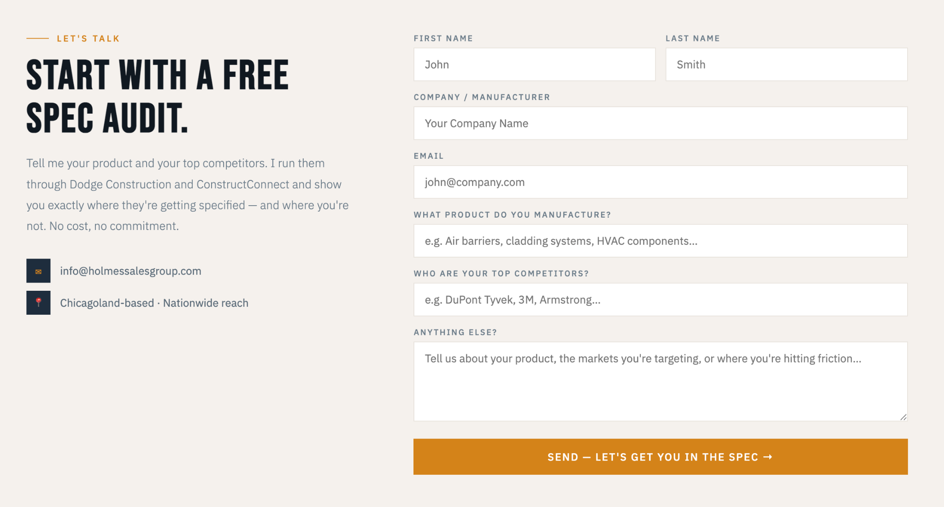

Let's Talk
Start With a Free Spec Audit.
Tell me your product and your top competitors. I run them through Dodge Construction and ConstructConnect and show you exactly where they're getting specified — and where you're not. No cost, no commitment.
✉ info@holmessalesgroup.com
📍 Chicagoland-based · Nationwide reach
First Name
Placeholder: John
Last Name
Placeholder: Smith
Company / Manufacturer
Placeholder: Your Company Name
Email
Placeholder: john@company.com
What Product Do You Manufacture?
Placeholder: e.g. Air barriers, cladding systems, HVAC components…
Who Are Your Top Competitors?
Placeholder: e.g. DuPont Tyvek, 3M, Armstrong…
CSI Six Digit Code
Example: 07 42 13

Anything Else?
Placeholder: Tell us about your product, the markets you're targeting, or where you're hitting friction…
Send — Let's Get You in the Spec →

